Set 9
Online Learning Activity Analysis
1. Import the dataset in R. Plot a histogram for Quiz_Score. Draw a boxplot of Quiz_Score by Course. Add title and labels. Interpret student performance.
AIM
To import the online learning activity dataset in R, plot a histogram for Quiz Score and draw a boxplot of Quiz Score by Course to analyze student performance.
Code:
# Create dataset
data <- data.frame(
Student_ID = c("L01","L02","L03","L04","L05","L06"),
Gender = c("Male","Female","Male","Female","Male","Female"),
Age = c(20,22,19,21,23,20),
Course = c("R","R","SQL","R","R","SQL"),
Study_Time = c(3.5,4.2,2.0,5.0,2.5,4.0),
Videos_Watched = c(12,15,8,18,9,14),
Quiz_Score = c(78,85,65,92,70,88),
Login_Date = c("2025-01-05","2025-01-05","2025-02-08",
"2025-02-08","2025-03-12","2025-03-12")
)
# Histogram of Quiz Score
hist(data$Quiz_Score,
main = "Distribution of Quiz Scores",
xlab = "Quiz Score",
ylab = "Number of Students",
col = "lightblue",
border = "black")
# Boxplot of Quiz Score by Course
boxplot(Quiz_Score ~ Course,
data = data,
main = "Quiz Score by Course",
xlab = "Course",
ylab = "Quiz Score",
col = "lightgreen")
Output:
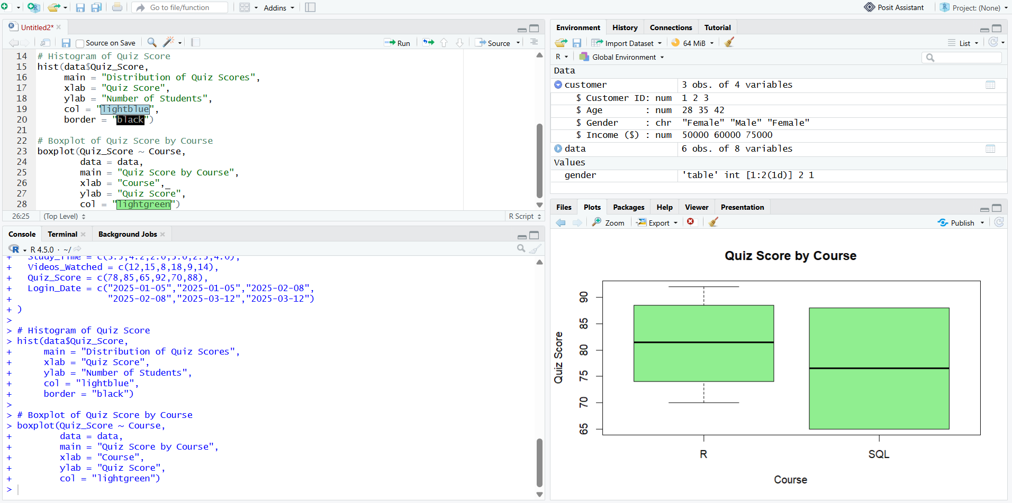
2. Create a scatter plot using R programming between Study_Time and Quiz_Score. Represent Videos_Watched using bubble size. Apply transparency. Explain the learning pattern.
AIM
To create a scatter plot between Study Time and Quiz Score using bubble size to represent Videos Watched and apply transparency to identify the learning pattern.

Code:
# Create dataset
data <- data.frame(
Student_ID = c("L01","L02","L03","L04","L05","L06"),
Gender = c("Male","Female","Male","Female","Male","Female"),
Age = c(20,22,19,21,23,20),
Course = c("R","R","SQL","R","R","SQL"),
Study_Time = c(3.5,4.2,2.0,5.0,2.5,4.0),
Videos_Watched = c(12,15,8,18,9,14),
Quiz_Score = c(78,85,65,92,70,88),
Login_Date = c("2025-01-05","2025-01-05","2025-02-08",
"2025-02-08","2025-03-12","2025-03-12")
)
# Scatter plot
symbols(data$Study_Time,
data$Quiz_Score,
circles = data$Videos_Watched / 20,
inches = 0.35,
bg = rgb(0.2, 0.5, 0.8, 0.5),
fg = "black",
xlab = "Study Time (hrs)",
ylab = "Quiz Score",
main = "Study Time vs Quiz Score",
xlim = c(1.5, 5.5),
ylim = c(60, 95))

Output:
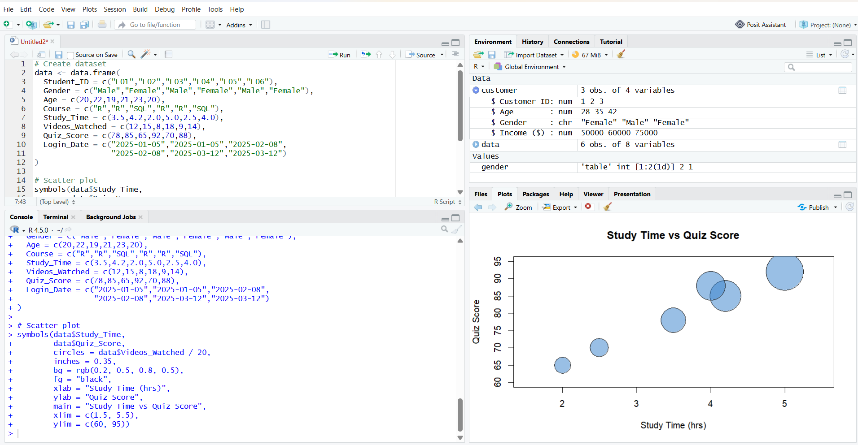
3. Using R programming, convert Login_Date into Date format. Calculate average quiz score per month. Plot a line chart. Apply moving average smoothing. Identify the trend.
AIM
To convert Login Date into date format, calculate the average quiz score per month, plot a line chart, apply moving average smoothing, and identify the trend.
Code:
# Create dataset
data <- data.frame(
Student_ID = c("L01","L02","L03","L04","L05","L06"),
Gender = c("Male","Female","Male","Female","Male","Female"),
Age = c(20,22,19,21,23,20),
Course = c("R","R","SQL","R","R","SQL"),
Study_Time = c(3.5,4.2,2.0,5.0,2.5,4.0),
Videos_Watched = c(12,15,8,18,9,14),
Quiz_Score = c(78,85,65,92,70,88),
Login_Date = c("2025-01-05","2025-01-05","2025-02-08",
"2025-02-08","2025-03-12","2025-03-12")
)
# Convert Login_Date into Date format
data$Login_Date <- as.Date(data$Login_Date)
# Extract month
data$Month <- format(data$Login_Date, "%Y-%m")
# Calculate average quiz score per month
monthly_avg <- aggregate(Quiz_Score ~ Month,
data = data,
FUN = mean)
# Display monthly average
print(monthly_avg)
# Calculate 2-month moving average
monthly_avg$Moving_Average <- c(
NA,
mean(monthly_avg$Quiz_Score[1:2]),
mean(monthly_avg$Quiz_Score[2:3])
)
# Create numeric positions for months
x <- 1:nrow(monthly_avg)
# Line chart
plot(x,
monthly_avg$Quiz_Score,
type = "o",
xaxt = "n",
xlab = "Month",
ylab = "Average Quiz Score",
main = "Monthly Average Quiz Score",
ylim = c(70, 90))
# Add month names to X-axis
axis(1,
at = x,
labels = monthly_avg$Month)
# Add moving average line
lines(x,
monthly_avg$Moving_Average,
type = "o",
lty = 2)
# Add legend
legend("bottomright",
legend = c("Average Quiz Score", "Moving Average"),
lty = c(1, 2),
pch = 1)
output:
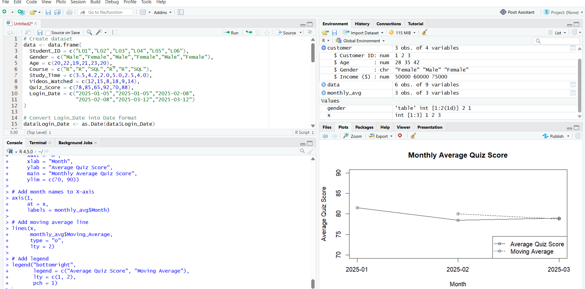
4. Import Online_Learning_Activity.csv into Tableau. Create a bar chart showing average quiz score by Course. Create a scatter plot (Study Time vs Quiz Score). Add filter for Gender and Course. Design a mini interactive dashboard.
Output:
